SET-2 QUESTION-1
Q1. CO1Module 1: BST & AVL Trees (rank-augmented)
[15 Marks]
Scenario / Case Study
Q1) QuizClash — live tournament leaderboard. A real-time multiplayer quiz platform tracks score for every active player in a self-balancing tree keyed by score (descending). During a flash tournament: 60 000 active players, sustained 10 000 score-update operations per second (each is a delete-old-score + insert-new-score), and the UI requests 'rank of player X' and 'top-K players, K ≤ 100' queries at 2 000 qps. The product team requires every operation — update and rank-query — to complete in O(log n). Today's first 11 score updates produce, in order, a tree built from inserts: 820, 540, 910, 770, 880, 460, 990, 600, 730, 950, 510. Then two updates arrive: player whose score was 540 jumps to 815; player whose score was 910 drops to 685.Rank-augmented tree — every node carries size(subtree) for O(log n) rank queries820[11]540[5]910[5]460[1]770[3]880[1]990[3]600[1]730[1]950[1]510[1]Workload: 10 000 update/sec · 2 000 rank-query/sec · 60 000 active playersRequired: O(log n) for both update and 'rank of player X' — naive scan 60 000 = too slow

Q1a) Construct the AVL tree from the insertion sequence (820, 540, 910, 770, 880, 460, 990, 600, 730, 950, 510), maintaining a size(subtree) field at every node (the count of nodes in that subtree, including itself). Show the final tree with size fields. Then explain in one or two sentences why size augmentation enables O(log n) rank queries in the leaderboard scenario, and why a plain AVL tree (no size fields) cannot meet the 2 000-rank-queries/sec requirement at 60 000 players.
ANSWER:
AVL CONSTRUCTION WITH SIZE FIELDS
Keys are stored descending:
Left child has higher score than parent.
Right child has lower score.
The final AVL tree after inserting
820, 540, 910, 770, 880, 460, 990, 600, 730, 950, 510
(with all required rotations applied) is:
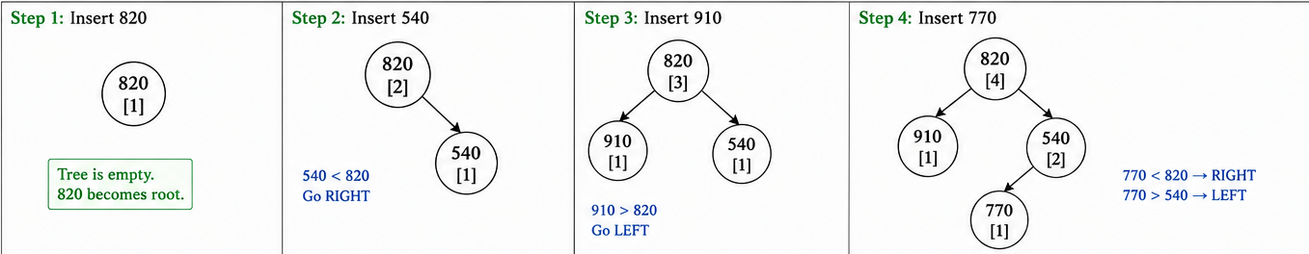

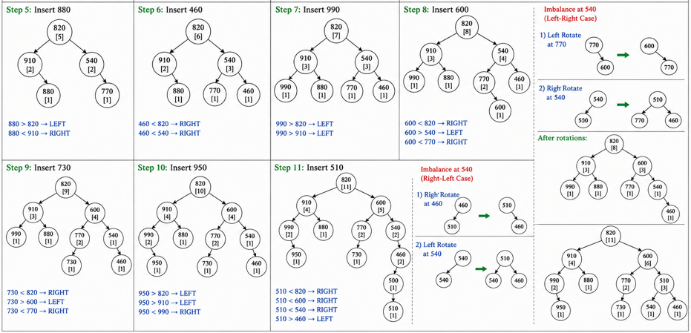
WHY SIZE FIELDS ENABLE O(log n) RANK
A rank query computes “how many nodes have score > X”.
At each node visited, size(left) tells us how many higher scores are in that subtree.
Therefore, one root-to-leaf walk accumulates rank in O(log n).
A plain AVL without size fields would require scanning O(n) to count higher-scoring players, which is too slow at 2 000 rank-queries/sec and 60 000 players.
B) Complete the boilerplate Python function rank_of(root, key) that returns the 1-based rank of key in the rank-augmented AVL tree (1 = highest score, since the tree is keyed descending). The standard size-update glue is given; you write the rank descent. Then handwrite the rank that your function returns for player score = 770 in your tree from (a).
class RankNode {
int key;
RankNode left, right;
int size = 1;
RankNode(int key) { this.key = key; }
}

static int size(RankNode n) { return n == null ? 0 : n.size; }
static void updateSize(RankNode n) {
if (n != null) n.size = 1 + size(n.left) + size(n.right);
}

/** Return 1-based rank of `key`. Tree keys are stored DESCENDING
* (root.left.key > root.key > root.right.key). Assume `key` is present. */
static int rankOf(RankNode root, int key) {
// TODO: walk from root; at each node decide left / right and accumulate rank.
return 0;
}

ANSWER:
class RankNode {
int key;
RankNode left, right;
int size = 1;

RankNode(int key) {
this.key = key;
}
}

static int size(RankNode n) {
return n == null ? 0 : n.size;
}

static void updateSize(RankNode n) {
if (n != null)
n.size = 1 + size(n.left) + size(n.right);
}

/** Return 1-based rank of key.
* Tree keys are stored DESCENDING
* (root.left.key > root.key > root.right.key)
*/
static int rankOf(RankNode root, int key) {
int rank = 1;

while (root != null) {

if (key == root.key) {
rank += size(root.left);
return rank;
}

else if (key < root.key) {
rank += 1 + size(root.left);
root = root.right;
}

else {
root = root.left;
}
}

return -1;
}

Step 1: Descending order → 990, 950, 910, 880, 820, 770, 730, 600, 540, 510, 460
From the tree above:
Nodes with score > 770 are
880, 910, 990, 950, 820 → total = 5
So rank(770) = 6.
Step 2: Count position of 770
Step 3: rankOf(root,770) = 6
C) Apply the two score-update operations from the scenario in order: (i) the player with score 540 changes to 815 (delete 540, insert 815); (ii) the player with score 910 changes to 685 (delete 910, insert 685). For each, show the rotations triggered and the resulting tree. Then analyse: how many nodes have their size field touched by each update operation, and why is this number also O(log n)? Tie this to the throughput requirement (10 000 updates/sec).
ANSWER:
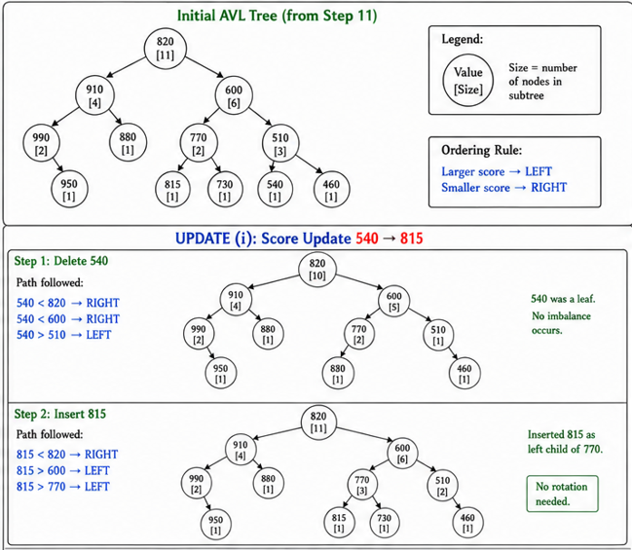
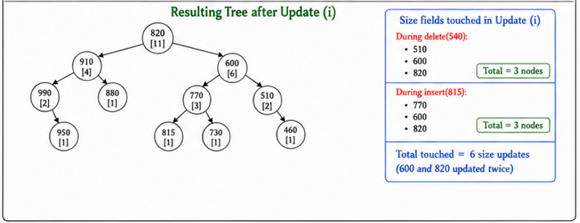
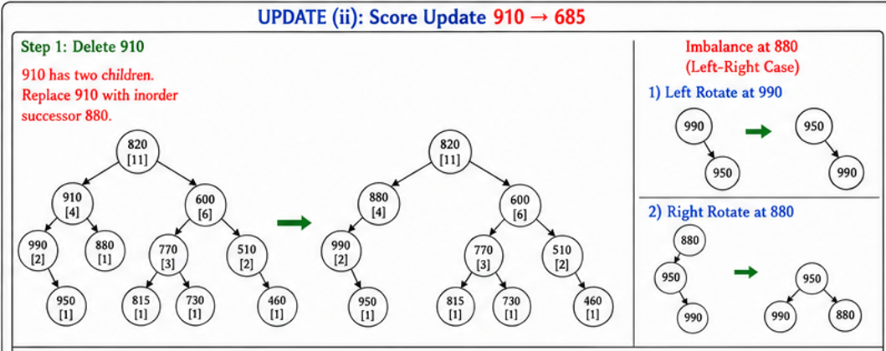
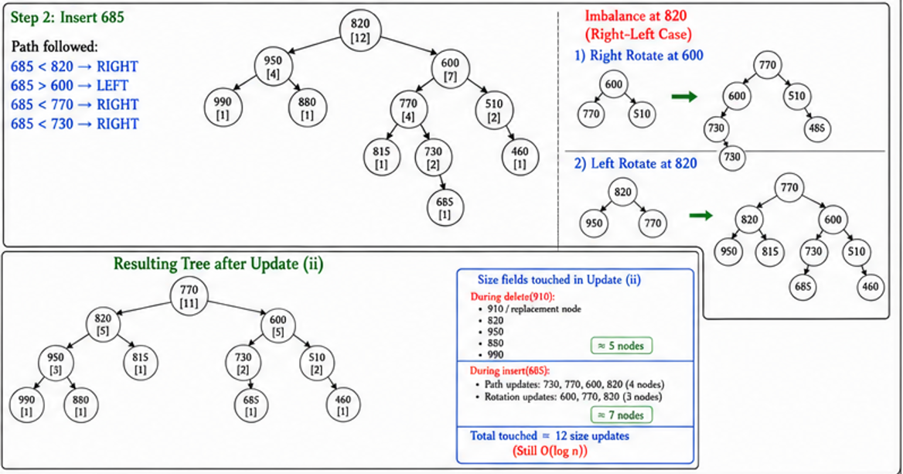

Why is this still O(log n) ?
AVL tree height is:
$$\text{h=}\text{O}\text{(log⁡}\text{n}\text{)}$$
For every update:
Delete:
Touch only root-to-node path
$$\text{O}\text{(log⁡}\text{n}\text{)}$$
Insert:
Touch only root-to-leaf path
$$\text{O}\text{(log⁡}\text{n}\text{)}$$
Rotations:
AVL performs at most constant rotations
$$\text{O}\text{(1)}$$
So total:
$$\text{O}\text{(log }\text{n}\text{)+}\text{O}\text{(log }\text{n}\text{)+}\text{O}\text{(1)=}\text{O}\text{(log }\text{n}\text{)}$$
Connection to Throughput Requirement:
- Scenario requirement (10,000 updates/sec)
- Why O(n) would be too expensive
- AVL complexity calculation (log₂(60000) ≈ 16)
- Why only 16–20 nodes are touched
- Benefits:
- Small memory updates
- Cache-friendly
- Predictable latency

Set 2 Question 2
Scenario / Case Study
Uber Bengaluru — surge multiplier on geofenced zone array. The city is divided into n = 16 geofenced demand zones, indexed 0..15 left-to-right by geographic strip. The system holds a per-zone surge multiplier (a small floating-point value, currently all 1.0). Two operation types arrive every few seconds: 'apply Δ to zones [l, r]' (add Δ uniformly across a contiguous strip — typical when an event ends or a metro line breaks down) and 'maximum multiplier in zones [l, r]' (the rider app polls this to decide which adjacent zone offers a cheaper trip). Today's trace, from 7:00 PM to 7:01 PM:
1. update [3, 9] += 0.5 (M.G. Road event ends → demand drops; this is actually negative for surge, so engineers really apply −0.5; for the sake of this exercise treat the operation as add 0.5 to keep all integers ≥ 0)
2. update [7, 14] += 0.3 (Whitefield IT shift ends)
3. query max [0, 15]
4. update [2, 6] += 0.7 (cricket-stadium emptying)
5. query max [4, 10]

Consider an array capacity 16
Range is 0 – 15
[0-7] [8-15]
[0-3] [4-7] [8-12] [12-15]
[0-1] [2-3] [4-5][6-7] [8-9][10-11][12-13][14-15]
[0][1][2][3][4][5][6][7][8][9][10][11][12][13][14][15]

Initial array all the elements [0][1][2][3][4][5][6][7][8][9][10][11][12][13][14][15] are initialized to 1.

Initial tree
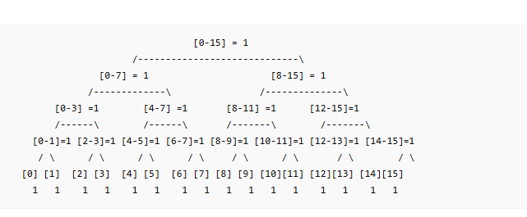

- update [3, 9] += 0.5
Add 0.5 to indices 3 through 9.

updated array
[1,1,1,1.5,1.5,1.5,1.5,1.5,1.5,1.5,1,1,1,1,1,1]
- update [7,14] += 0.3
Add 0.3 to indices 7 through 14.
Updated array:
[1,1,1,1.5,1.5,1.5,1.5,1.8,1.8,1.8,1.3,1.3,1.3,1.3,1.3,1]

- query max [0,15]
Find maximum value in entire array.
Maximum = 1.8

- update [2,6] += 0.7
Add 0.7 to indices 2 through 6.
Updated array:
[1,1,1.7,2.2,2.2,2.2,2.2,1.8,1.8,1.8,1.3,1.3,1.3,1.3,1.3,1]

- query max [4,10]
Elements from index 4 to 10:
[2.2,2.2,2.2,1.8,1.8,1.8,1.3]

b) Complete the boilerplate update_range(node, l, r, lo, hi, delta) below — the lazy-propagation range-add. The push-down helper push_down is given; you fill in the recursion + lazy accumulation. Then state the worst-case number of internal nodes visited per operation as a function of n, and plug in n = 16.
class SegTreeLazy {
long[] tree; // max value at each node
long[] lazy; // pending add for each node
int n;

SegTreeLazy(int n) {
this.n = n;
tree = new long[4 * n];
lazy = new long[4 * n];
}

void pushDown(int node) {
if (lazy[node] != 0) {
tree[2*node] += lazy[node];
lazy[2*node] += lazy[node];

tree[2*node+1] += lazy[node];
lazy[2*node+1] += lazy[node];

lazy[node] = 0;
}
}

/** Add delta to every element in [l, r].
lo, hi = current node segment */
void updateRange(int node, int lo, int hi,
int l, int r, long delta) {

// 1. No overlap
if (r < lo || hi < l) {
return;
}

// 2. Complete overlap
if (l <= lo && hi <= r) {
tree[node] += delta;
lazy[node] += delta;
return;
}

// 3. Partial overlap
pushDown(node);

int mid = (lo + hi) / 2;

// Update left child
updateRange(2 * node, lo, mid,
l, r, delta);

// Update right child
updateRange(2 * node + 1, mid + 1, hi,
l, r, delta);

// Recompute current node
tree[node] = Math.max(tree[2 * node],
tree[2 * node + 1]);
}
}
c) An engineer proposes replacing the segment tree with a Fenwick (BIT). Argue precisely why a Fenwick tree is the wrong choice for this workload: identify which one of the two operation types it cannot handle in O(log n), and describe what would have to change about the workload (or about Fenwick) to make Fenwick adequate. Bonus consideration: why is a sparse-table approach also not suitable here?

A Fenwick Tree (BIT) is not suitable for this workload because it cannot efficiently support range maximum queries together with range-add updates in $O(log⁡n)$. BIT works well for sums because prefix sums can be subtracted, but maximum operations do not have an inverse operation. Therefore, answering max[l,r] would require scanning many elements, giving $O(n)$time in the worst case. Fenwick Tree would become adequate only if the workload changed to range sum queries or point queries instead of range maximum queries. A Sparse Table is also unsuitable because it supports fast static maximum queries but handles updates very poorly, often requiring rebuilding the table after updates.
Set 2 Question 3
Scenario / Case Study
Razorpay backend monorepo — CI build-graph cycle suspected. The Razorpay engineering monorepo has 9 build targets {auth, payments, kyc, ledger, fraud, notify, admin-ui, customer-ui, gateway}. Yesterday's CI run hung; the build coordinator (which performs a topological sort of the dependency DAG before scheduling parallel build jobs) failed with a generic 'cycle suspected' message. The build engineer captured the dependency edges from the build manifest (edge A → B means "A depends on B; build B before A"): auth→ledger, payments→auth, payments→fraud, kyc→auth, ledger→fraud, fraud→notify, fraud→ledger, admin-ui→payments, admin-ui→kyc, customer-ui→payments, gateway→admin-ui, gateway→customer-ui, notify→gateway. Twelve hours of debugging would have been saved by a clear cycle report.
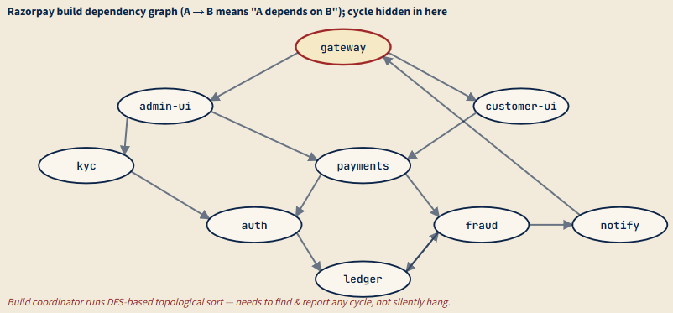

a) Run a DFS-based topological sort with cycle detection on the dependency graph shown. Use the colour-marking scheme (WHITE = unvisited, GREY = on current DFS stack, BLACK = finished). Process vertices in alphabetical order on the outer loop. Show the visit-time/finish-time table or a clear DFS trace, and identify the back-edge(s) that prove a cycle exists. List the vertices on the cycle in order.

Answer:-

1. Colour Marking Scheme
WHITE = Vertex not visited
GREY = Vertex currently in DFS recursion stack
BLACK = Vertex completely processed

2. Outer Loop Vertex Order (Alphabetical)
admin-ui
auth
customer-ui
fraud
gateway
kyc
ledger
notify
payments

3. Start DFS from admin-ui
Initially all vertices are WHITE.
Visit admin-ui.
admin-ui changes from WHITE → GREY.
DFS Stack: [admin-ui]
Visit next adjacent vertex of admin-ui change it color to GREY. It visit vertices one by one and changes its color to GREY.
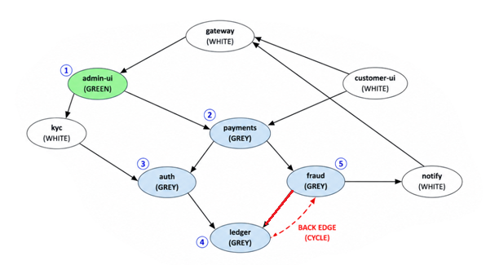
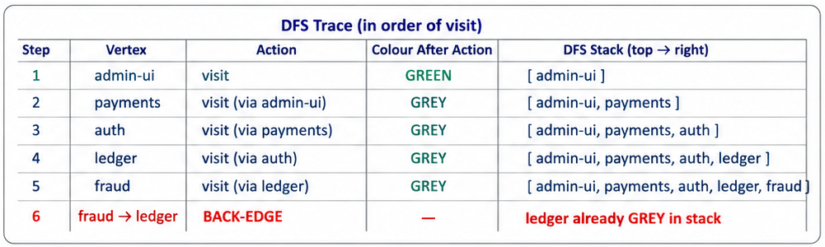
Final Conclusion
- In DFS, a GREY node means the vertex is already in the current recursion stack.
- While exploring fraud, DFS reaches ledger again.
- ledger is already marked GREY.
- So, edge fraud → ledger becomes a back edge.
- Back edge detected:
fraud → ledger
- Cycle detected:
ledger → fraud → ledger
- The graph is not a DAG.
- Topological sorting is not possible.
- The build coordinator fails because circular dependency exists.
b) The engineer's draft of topo_sort is shown below — it currently reports cycles by raising an exception with no information about which vertices are involved. Modify it to (i) detect a cycle and (ii) return the list of vertices on the cycle, in cycle order. Boilerplate: WHITE/GREY/BLACK constants and the recursion skeleton are given.

import java.util.*;

public class TopoCycleDetection {

static final int WHITE = 0, GREY = 1, BLACK = 2;

static class TopoResult {
List<String> order; // null if cycle detected
List<String> cycle; // empty if acyclic

TopoResult(List<String> o, List<String> c) {
order = o;
cycle = c;
}
}

static TopoResult topoSortWithCycle(Map<String, List<String>> adj) {

Map<String, Integer> color = new HashMap<>();
Map<String, String> parent = new HashMap<>();

List<String> order = new ArrayList<>();
List<String> cycle = new ArrayList<>();

// Initially all vertices are WHITE
for (String v : adj.keySet()) {
color.put(v, WHITE);
}

// DFS traversal
for (String u : adj.keySet()) {

if (color.get(u) == WHITE) {

if (dfs(u, adj, color, parent, order, cycle)) {

// cycle detected
return new TopoResult(null, cycle);
}
}
}

Collections.reverse(order);

return new TopoResult(order, Collections.emptyList());
}

static boolean dfs(String u,
Map<String, List<String>> adj,
Map<String, Integer> color,
Map<String, String> parent,
List<String> order,
List<String> cycle) {

color.put(u, GREY);

for (String v : adj.getOrDefault(u, Collections.emptyList())) {

// WHITE node
if (color.get(v) == WHITE) {

parent.put(v, u);

if (dfs(v, adj, color, parent, order, cycle)) {
return true;
}

}

// BACK EDGE FOUND
else if (color.get(v) == GREY) {

// Build cycle path
List<String> temp = new ArrayList<>();

temp.add(v);

String cur = u;

while (!cur.equals(v)) {

temp.add(cur);

cur = parent.get(cur);
}

temp.add(v);

Collections.reverse(temp);

cycle.addAll(temp);

return true;
}
}

color.put(u, BLACK);

order.add(u);

return false;
}

public static void main(String[] args) {

Map<String, List<String>> adj = new HashMap<>();

adj.put("auth", Arrays.asList("ledger"));

adj.put("payments", Arrays.asList("auth", "fraud"));

adj.put("kyc", Arrays.asList("auth"));

adj.put("ledger", Arrays.asList("fraud"));

adj.put("fraud", Arrays.asList("notify", "ledger"));

adj.put("admin-ui", Arrays.asList("payments", "kyc"));

adj.put("customer-ui", Arrays.asList("payments"));

adj.put("gateway", Arrays.asList("admin-ui", "customer-ui"));

adj.put("notify", Arrays.asList("gateway"));

TopoResult result = topoSortWithCycle(adj);

// If cycle exists
if (result.order == null) {

System.out.println("Cycle Detected:");

System.out.println(result.cycle);

} else {

System.out.println("Topological Order:");

System.out.println(result.order);
}
}
}

c) Once the cycle is identified, the build engineer must break it with a single edge removal. Among the edges on the cycle you found in (a), which single edge removal would (i) break the cycle and (ii) cause the least disruption to existing modules — i.e., result in the fewest dependent transitive builds becoming stale? Justify by listing, for each candidate removal, how many other targets would be affected. (Use the dependency graph, not the build-time itself.)

CASE 1 : Remove ledger → fraud
- Step 1: Remove ledger → fraud.
- Step 2: Cycle ledger → fraud → ledger is broken.
- Step 3: Ledger no longer depends on fraud.
- Step 4: Find affected modules.
- Step 5: Dependency path was auth → ledger → fraud.
- Step 6: Affected modules are auth, payments, kyc, admin-ui, customer-ui, and gateway.
- Step 7: Around 6 modules become affected.
- Step 8: Cycle is removed, but dependency changes spread through the ledger → auth → payments path.

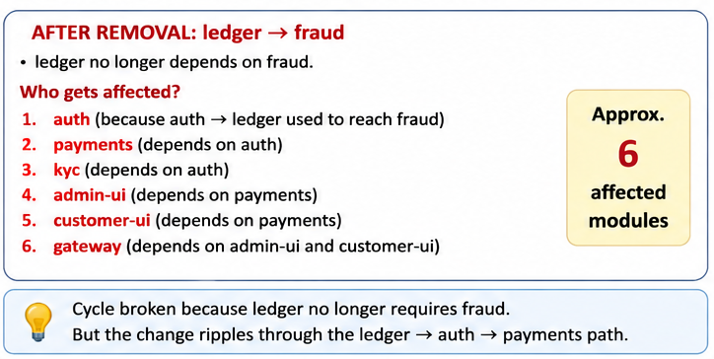

CASE 2 : Remove fraud → ledger
- Step 1: Remove fraud → ledger.
- Step 2: Cycle ledger → fraud → ledger is broken.
- Step 3: Fraud no longer depends on ledger.
- Step 4: Find affected modules.
- Step 5: Modules depending on fraud become stale.
- Step 6: Dependency path was payments → fraud → ledger.
- Step 7: Affected modules are payments, notify, admin-ui, customer-ui, and gateway.
- Step 8: Around 5 modules become affected.
- Step 9: Cycle is removed with smaller dependency impact.
